**Software Requirements Specification**

For

**South-Pride-Products**

Version 1.0

Prepared by: **D.M.D.T Dissanayake**

Reg No: [**PR23104661**](javascript:void(0))

This document outlines the Software Requirements Specification (SRS) for an e-commerce platform designed to facilitate the sale of various household goods, primarily focusing on spices and related products. The platform aims to provide a seamless online shopping experience, enabling users to browse, filter, and purchase items securely. It will also include features for inventory management, customer account management, and order processing, ensuring efficient operations and customer satisfaction.

11/10/2024

**Table of Contents**

Table of Contents —**----------------------------------------------------------------------------------------** 2

Revision History —**----------------------------------------------------------------------------------------** 4

# **1. Introduction**

## 1.1 Purpose ----------------------------------------------------------------------------------- 5

## 1.2 Intended Audience and Reading Suggestions ---------------------------------------------- 5

1.3 Project Scope -------------------------------------------------------------------------- 5

1.4 References —-------------------------------------------------------------------------------- 5

# **2. Overall Description**

## 2.1 Product Perspective —----------------------------------------------------------------------- 8

## 2.2 Product Features —----------------------------------------------------------------------- 9

## 2.3 Operating Environment —-------------------------------------------------------------- 9

## 2.4 Design and Implementation Constraints —--------------------------------------------10

## 2.5 Assumptions and Dependencies —-----------------------------------------------------10

## 

# **3. System Analysis and Design**

## 3.1 Benefits of the proposed project —-----------------------------------------------------11

## 3.2 Target Audience —-----------------------------------------------------------------------11

### 3.3 Functional requirements —-----------------------------------------------------------------------12

### 3.4 Non-functional Requirements —------------------------------------------------------------- 13

3.5 Development System Requirement —----------------------------------------------------14

3.5.1 System Software Requirement —-------------------------------------------------------------14

3.5.2 System Hardware Requirement —----------------------------------------------------14

**3.6 System Design**

3.6.1 Use case diagram and description —----------------------------------------------------16

3.6.2 Entity Relationship Design —-------------------------------------------------------------16

**4. Other Nonfunctional Requirements**

## 4.1 Performance Requirements —------------------------------------------------------------17

## 4.2 Safety Requirements —--------------------------------------------------------------------17

## 4.4 Software Quality Attributes —------------------------------------------------------------17

Revision History

|  |  |  |  |
| --- | --- | --- | --- |
| **Name** | **Date** | **Reason For Changes** | **Version** |
| South-Pride-Products | 11-10-2024 | - | 1.0 |
|  |  |  |  |

# 

# 

# 

# 

# 

# **1.** **Introduction**

## **1.1** **Purpose**

## The purpose of this e-commerce application is to provide a digital platform for the sale and distribution of household goods, with a primary focus on spices. It enables customers to easily browse and purchase a wide range of products from the comfort of their homes. The platform aims to streamline the shopping experience by offering features such as product filtering, secure payment processing, and efficient order management. Additionally, it supports inventory management for sellers, ensuring accurate stock tracking and customer satisfaction through timely order fulfillment.

## **1.2** **Intended Audience and Reading Suggestions**

* **Customers** – Individuals looking to purchase household goods, particularly spices, who seek a convenient, secure, and user-friendly online shopping experience.
* **Administrators** – The platform’s management team responsible for listing products, managing inventory, overseeing operations, handling customer accounts, and ensuring smooth order fulfillment.
* **Developers** – Software engineers responsible for maintaining, updating, and scaling the platform to meet customer and business needs.

**1.3** **Project Scope**

**Project Scope**

The scope of this e-commerce platform includes the following key functionalities and features:

1. **Product Listing and Management**

* Administration is responsible for listing, editing, and managing household products, including spices and other related items.
* Products will be categorized for easier browsing and filtering by customers.

1. **User Account Management**

* Customers can create and manage personal accounts to track orders, view purchase history, and manage shipping details.

1. **Product Search and Filtering**

* The platform will provide search functionality with filtering options to help customers easily find products based on categories, price, and availability.

1. **Shopping Cart and Checkout**

* Customers can add products to their cart, review their order, and proceed to checkout with secure payment processing.

1. **Order Management**

* The platform will support efficient order processing, including order confirmation, tracking, and notifications to both customers and the administration.

1. **Inventory Management**

* The platform will automatically update inventory levels to ensure accurate stock tracking for all listed products.

1. **Responsive Design**

* The platform will be optimized for both desktop and mobile devices to provide a seamless user experience across different screen sizes.

1. **Security**

* Secure handling of user data and transactions will be a top priority, with encryption and authentication measures in place.

1. **Analytics and Reporting**

* The platform will offer basic analytics and reporting features for the administration to monitor sales, customer behavior, and stock levels.

**Project Descopes**

1. **Multi-Seller Support**

* The platform will not include functionality for multiple sellers or vendors. There is only one seller, and the administration is responsible for managing all product listings.

1. **Third-Party Marketplace Integration**

* The platform will not integrate with other e-commerce marketplaces (e.g., Amazon, eBay) for product listings or sales.

1. **Subscription Services**

* The platform will not support subscription-based purchases, such as recurring orders or memberships.

1. **Customer Chat or AI Support**

* There will be no integration of live chat or AI-powered customer support tools such as chatbots in the initial release.

# **2.** **Overall Description**

## **2.1** **Product Perspective**

This e-commerce platform is a web-based system designed to facilitate the sale of household goods, particularly spices. The platform will be developed as a single-seller model, with administration fully responsible for managing product listings, orders, and customer interactions.

**The software will handle various tasks such as:**

## **1. Product Management**

* Administration will be able to add, update, and remove household products (e.g., spices) from the platform.
* Manage product details such as descriptions, prices, images, and stock levels.

## **2. User Registration and Management**

* The platform will allow customers to create accounts, log in, manage their profiles, and track their orders.
* Administration can manage customer accounts, including viewing and handling any issues with orders.

## **3. Product Browsing and Searching**

* Customers can browse the product catalog and use filters (e.g., category, price) to find specific items.
* Search functionality will allow users to quickly locate products by keyword.

## **4. Shopping Cart Management**

* Customers can add products to a shopping cart, review items, and make modifications before checkout.

## **5.Checkout and Payment Processing**

* The platform will provide a secure checkout process, allowing customers to pay via integrated payment gateways.
* Handle payment confirmations and notify customers and administration of successful transactions.

## **6 Inventory Management**

* The platform will track stock levels for each product and automatically adjust inventory after purchases.
* Alerts will be available for low-stock items to help administrators manage restocking.

## **2.2** **Product Features**

The project encompasses the following key components:

**User-Friendly Interface**

* A clean, intuitive design that allows customers to easily navigate through product categories, search for items, and complete purchases.

**Product Catalog**

* A comprehensive display of household goods, with detailed product descriptions, high-quality images, pricing information, and stock availability.

**Shopping Cart Functionality**

* Customers can easily add or remove products from their cart, view item details, and adjust quantities before proceeding to checkout.

**Responsive Design**

* The platform will be optimized for various devices, including desktops and smartphones, providing a consistent experience across all platforms.

**Admin Dashboard**

* A dedicated interface for administrators to manage product listings, track orders, and view sales reports and customer data.

## **2.3** **Operating Environment**

**Database Environment**

* MongoDB will be used as the NoSQL database to store user data, product information, orders, and inventory:
* Database Management System: MongoDB, providing flexible document storage for handling various data structures.

**Client Environment**

* Customers will access the platform through standard web browsers (e.g., Chrome, Firefox, Safari, Edge) on various devices.

**Security Environment**

* Access Controls: Role-based access for administrators and secure authentication for users, leveraging JWT (JSON Web Tokens) for session management.

## **2.4** **Design and Implementation Constraints**

At the preliminary stage we do not have any identified design and implementation constraints.

## **2.5** **Assumptions and Dependencies**

**User Accessibility**

**Assumption:** Users will have reliable internet access to interact with the e-commerce platform seamlessly.

**Dependency:** The platform’s performance is reliant on a stable internet connection, server uptime, and bandwidth provided by the hosting service.

**Device Compatibility**

**Assumption:** Users will access the platform using modern devices, including desktops, laptops, tablets, and smartphones.

**Dependency:** The responsive design and user interface must be optimized to support various screen sizes and resolutions.

**User Training**

**Assumption:** Administrators will have the necessary training to manage the platform effectively, including product management and order processing.

**Dependency:** Comprehensive training materials and sessions must be provided to ensure administrators are proficient in using the platform's features.

# **3.** **System Analysis and Design**

## **3.1** **Benefits of the proposed project**

**Convenience**

* Users can shop for household items from the comfort of their homes at any time, eliminating the need to travel to physical stores.

**Time Savings**

* The ability to quickly search for and find specific items online saves users valuable time compared to browsing in-store.

**Detailed Product Information**

* Users have access to comprehensive product descriptions, images, and specifications, enabling informed purchasing decisions.

**Secure Transactions**

* The platform ensures secure payment processing, protecting users' financial information during transactions.

## **3.2** **Target Audience**

**Household Consumers**

* Individuals and families looking to purchase household items such as spices, kitchen supplies, and other essential goods for daily use.

**Health-Conscious Shoppers**

* Customers seeking natural or organic products, such as spices, for cooking and healthy living.

**Cooks and Home Chefs**

* Cooking enthusiasts or professional chefs looking for high-quality spices and ingredients to enhance their culinary creations.

**Online Shoppers**

* Tech-savvy consumers who prefer the convenience of shopping online rather than visiting physical stores.

**Catering and Food Service Businesses**

* Small businesses or catering services seeking to purchase bulk quantities of spices and ingredients for their operations.

**Local Communities**

* Residents of local areas looking to support local sellers and purchase products that may not be available in larger retail chains.

**Environmental Advocates**

* Consumers interested in sustainable and ethically sourced products, who prioritize eco-friendly packaging and practices.

### **3.3 Functional requirements**

**User Registration and Login**

* Users must be able to register an account by providing personal information such as name, email, and password.
* Users must be able to log in using their registered credentials.

**Product Display**

* The web page should display a list of household items with images, names, prices, and brief descriptions.
* Users should be able to click on a product to view detailed information.

**Search Functionality**

* Users should have the option to filter results by categories.

**Shopping Cart Management**

* Users can add items to the shopping cart from the product listing or detail pages.
* Users can view, update quantities, and remove items from the cart before checkout.

**Checkout Process**

* Users must be able to proceed to checkout, providing shipping and payment information.
* The system should validate payment details and process the transaction securely

**User Profile Management**

* Users can view and edit their profile information, including shipping addresses and payment methods.

**Admin Product Management**

* Administrators can add, update, or delete products, including images and descriptions, from the web page.

### **3.4 Non-functional Requirements**

**Usability**

* The web page must have an intuitive layout and navigation structure to enhance user experience.
* The design should be responsive, ensuring compatibility with various devices (desktops, smartphones).

**Security**

* All user data, especially personal and payment information, must be encrypted during transmission.
* The web page must implement secure authentication methods and protect against common security threats.

**Maintainability**

* The codebase should be modular and well-documented to facilitate updates and maintenance

**3.5 Development System Requirement**

**3.5.1 System Software Requirement**

|  |  |
| --- | --- |
| **Application Name** | **Description** |
| ExpressJs | Web framework for Node.js, used for building the backend and handling routing, middleware, and server-side logic. |
| ReactJs | |  | | --- | | JavaScript library for building user interfaces,  used for implementing the frontend of the  application. | |
| NodeJs | |  | | --- | | JavaScript runtime environment for executing  JavaScript code on the server side, enabling the  use of JavaScript for backend development. | |
| MongoDB | |  | | --- | | NoSQL database for storing and managing  application data, used to maintain the database  for the e-commerce platform. | |

|  |  |
| --- | --- |
| |  | | --- | |  | |

**3.5.2 System Hardware Requirement**

Software can be applicable through every smart device.

**3.6 System Design**

**3.6.1 Use case diagram and description**

Use Case Reference - <https://drive.google.com/file/d/1NJQ2Q_RZpd-iddIeLITsC19NzFD8zKtc/view?usp=sharing>

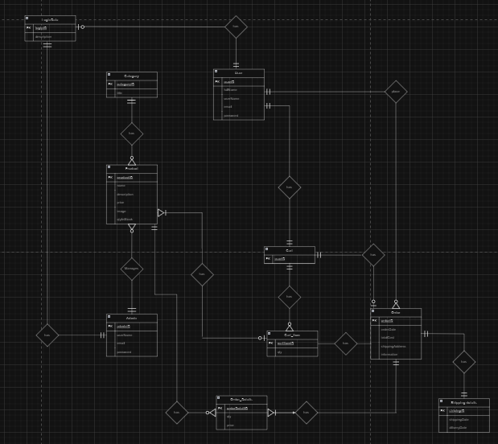

**3.6.2 Entity Relationship Design**

ER Reference **-** <https://drive.google.com/file/d/1NJQ2Q_RZpd-iddIeLITsC19NzFD8zKtc/view?usp=sharing>

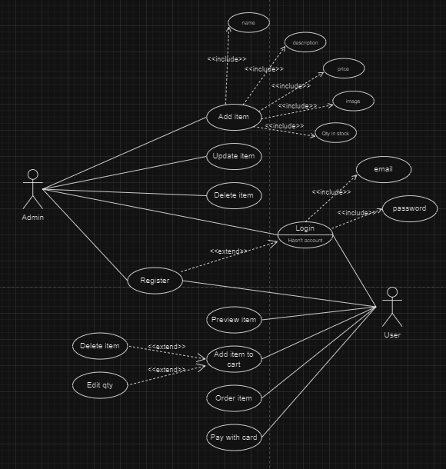

**4.** **Other Nonfunctional Requirements**

## **4.1** **Performance Requirements**

* We are expecting 50 customers in the first month and aim to expand our customer base further within three months after completing the project.
* The web page should load within **2 seconds** under normal network conditions. This ensures a responsive user experience.

## **4.2** **Safety Requirements**

* Payment transactions must be processed through secure payment that comply with the Payment Card Industry Data Security Standard (PCI-DSS)
* Role-based access control (RBAC) should be enforced, ensuring that users have access only to the features and data necessary for their role.
* All user inputs should be validated and sanitized to prevent common vulnerabilities such as SQL injection, cross-site scripting (XSS), and cross-site request forgery (CSRF).

## **4.3** **Software Quality Attributes**

**Performance**

* The system should deliver fast response times, ensuring quick page loads and efficient processing of user requests, even under high load conditions.

**Usability**

* The user interface should be intuitive and user-friendly, enabling users to navigate the site easily and complete their tasks with minimal effort.

**Maintainability**

* The codebase should be organized, well-documented, and modular, allowing for easy updates, bug fixes, and enhancements without significant efforts

**Flexibility**

* The architecture should be adaptable to changing requirements, allowing for easy incorporation of new features and enhancements based on user feedback and market trends.